Assessment Schedule – 2013

Calculus: Apply differentiation methods in solving problems (91578)

Evidence Statement
One | Expected Coverage | Achievement | Merit | Excellence
(a) | 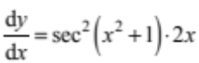 | Correct derivative.
(b) | 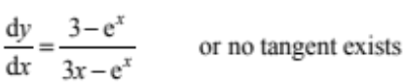  At x = 0 gradient = –2 | Correct solution with correct derivative shown.
(c) | 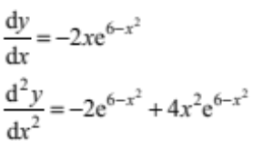  Point of inflection when 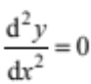  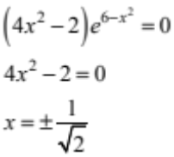 | Correct 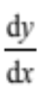 | Correct solution with correct first and second derivatives.  not required, accept positive answer only.
(d) | 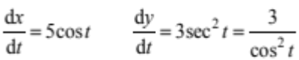  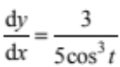  At 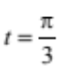, 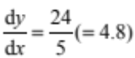  gradient of normal = 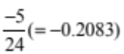 | Correct 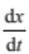 and 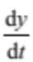. | Correct solution  including all correct derivatives.
(e) | 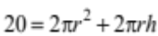  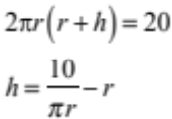  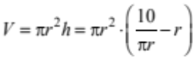  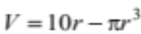  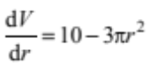  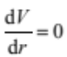 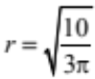 or 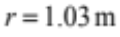  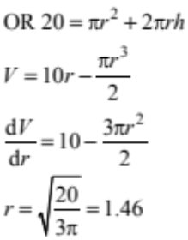 |  | Equation for volume in terms of 1 variable found, and differentiated correctly. | Problem solved including correct derivative.

NØ = No response / no relevant evidence
N1 = ONE question demonstrating limited knowledge of differentiation techniques
N2 = ONE correct derivative
A3 = TWO of Achievement
A4 = THREE of Achievement
M5 = ONE of Merit
M6 = TWO of Merit
E7 = Excellence with minor errors ignored
E8 = Excellence correct

Two | Expected Coverage | Achievement | Merit | Excellence
(a) | 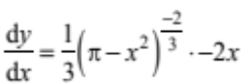  or 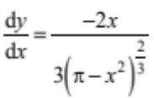 | Correct derivative.
(b) | 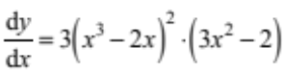  At x = 1 , 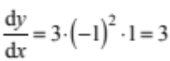  At x = 1, 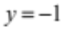  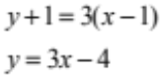 | Correct solution with correct derivative shown.
(c) | 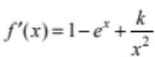  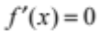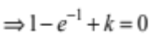  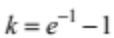  Or 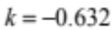 | Correct derivative. | Correct value for k and correct derivative.
(d)(i)  (ii)  (iii) | 1. x = 1  2. x > 3  3. –2, –1, 3  –3  Does not exist. |  | THREE correct answers (out of 5).
(e) | 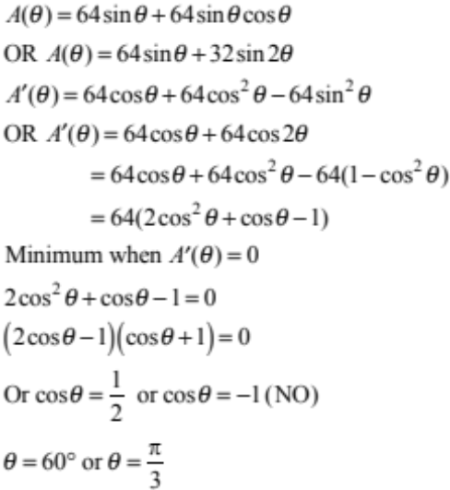 |  | Correct derivative. | Correct solution with correct derivatives.

NØ = No response / no relevant evidence
N1 = ONE question demonstrating limited knowledge of differentiation techniques
N2 = ONE correct derivative
A3 = TWO of Achievement
A4 = THREE of Achievement
M5 = ONE of Merit
M6 = TWO of Merit
E7 = Excellence with minor errors ignored
E8 = Excellence correct

Three | Expected Coverage | Achievement | Merit | Excellence
(a) | 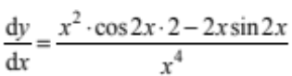 | Correct derivative.
(b) | 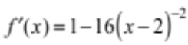  Turning point when  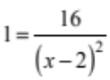  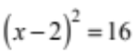  or | Correct solution with correct derivative.
(c) | 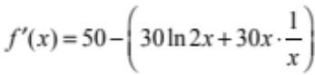  Maximum when  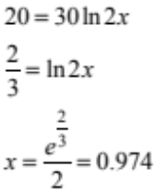 | Correct derivative. | Correct solution with correct derivative.
(d) | For the curve, 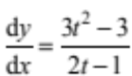  Normal parallel to the y-axis means tangent parallel to the x-axis.  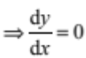  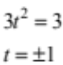  point (0,–2)  point (2,2) | Correct expression for 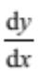 | Correct solution with correct derivative.
(e) | 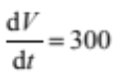  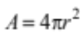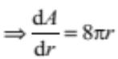  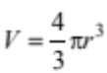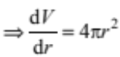  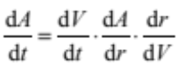  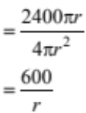  A = 7500 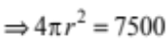  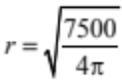= 24.43 cm  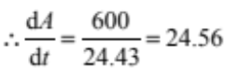 cm² s^{–1} | Correct expressions for  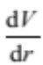 and 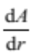 | Correct expressions for  , and  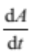 | Correct solution along with  correct expressions for  , and

NØ = No response / no relevant evidence
N1 = ONE question demonstrating limited knowledge of differentiation techniques
N2 = ONE correct derivative
A3 = TWO of Achievement
A4 = THREE of Achievement
M5 = ONE of Merit
M6 = TWO of Merit
E7 = Excellence with minor errors ignored
E8 = Excellence correct

Judgement Statement
 | Not Achieved | Achievement | Achievement  with Merit | Achievement  with Excellence
Score range | 0 – 8 | 9 – 13 | 14 – 20 | 21 – 24

